" כמין ספינה רוקדת"
מנחות צד:
By: Eli Genauer
The Gemara discusses the shape of the Lechem Hapanim and records two opinions

איתמר לחם הפנים כיצד עושין אותו How was the Lechem HaPanim prepared? ?

צד׃ רבי חנינא אמר כמין תיבה פרוצה, ר' יוחנן אמר כמין ספינה רוקדת
Rav Chanina says: It was rectangular, with a wide base and two parallel walls with an open space between them, like a box that is open on two sides. Rav Yocḥanan says that the Lechem HaPanim was like a rocking boat, i.e., a triangular-shaped boat with a narrow base from which two walls rise at angles. Since the boat does not have a wide base it rocks from side to side.
On the words כמין תיבה פרוצה Rashi comments
שניטל כיסויה ושתי דופנותיה זו כנגד זו כך הלחם היו לו בּ’ דפנות ושוליים רחבים כזה
(A box) whose covering has been taken away, and its two sides are opposite each other, so too the bread had two sides and a broad bottom like this
On the words כמין ספינה רוקדת, Rashi comments
קווי"ש, ואין לה שוליים אלא מלמעלה רחבה ומלמטה כלה והולכת עד כאצבע כזה ובּ' ראשיה חדין והולכין וגבוהין למעלה ואין נוגעין במים ולהכי קרי לה רוקדת שמרקדת והולכת מהר:
Rashi first uses an old French word קווי"ש to describe the ספינה רוקדת. “Otzar Loazei Rashi” ( second volume, page 151) renders it קויי״ט “cojet” and says it is a סירונת, a small boat. The Oz Vehadar Murchav edition of Menachot translates the French similarly as סירה קטנה.
Rashi continues: And it had no bottom, rather, on top it was broad, and on the bottom it tapered downwards until on the bottom it was like a finger, like this: And both of the tops are narrow and go upward and do not touch the water, and therefore it is called “dancing” ( or rocking) because it “dances” and moves quickly.
As you can see, the words of Rashi are not easy to translate, making the picture after the word כזה in the Rashi quite critical to understanding what he means.

The classic Vilna Shas on this section looks like this. The ספינה רוקדת is depicted as being shaped like a “V”.
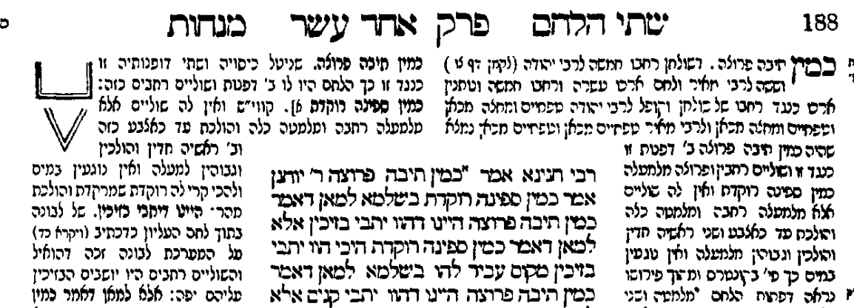
What was the source for this “V” shaped picture of the ספינה רוקדת which is found in our Rashi?
We know that the original Ktav Yad of Rashi had a diagram because Tosafot refers to it by saying
"ומה שצייר בקונטרס צורתו כזה". But we do not have any Ktav Yad of Tosafot to know what Tosafot drew after the word כזה. The picture in our editions is the same V shape as in our Rashi.
The first printed edition of Menachot was in 1522 by Daniel Bomberg in Venice. The Bomberg editors were certainly working from a manuscript. As you can see, they left space for a picture after the word כזה in the Rashi which explains תיבה פרוצה. They also seemed to leave space for another picture in the Rashi which discusses ספינה רוקדת. ( Although they did not include the word כזה before it)
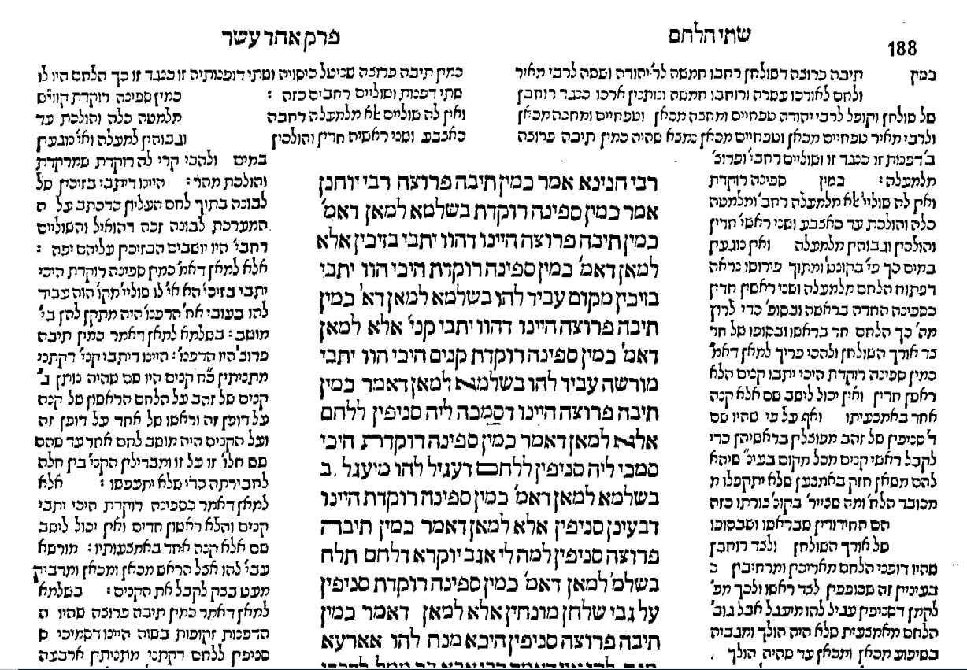
Throughout the next approximately 200 years all printed editions of the Talmud left space for diagrams of these two opinions, but did not include the diagrams themselves.
Here is Menachot printed in Cracow in 1605
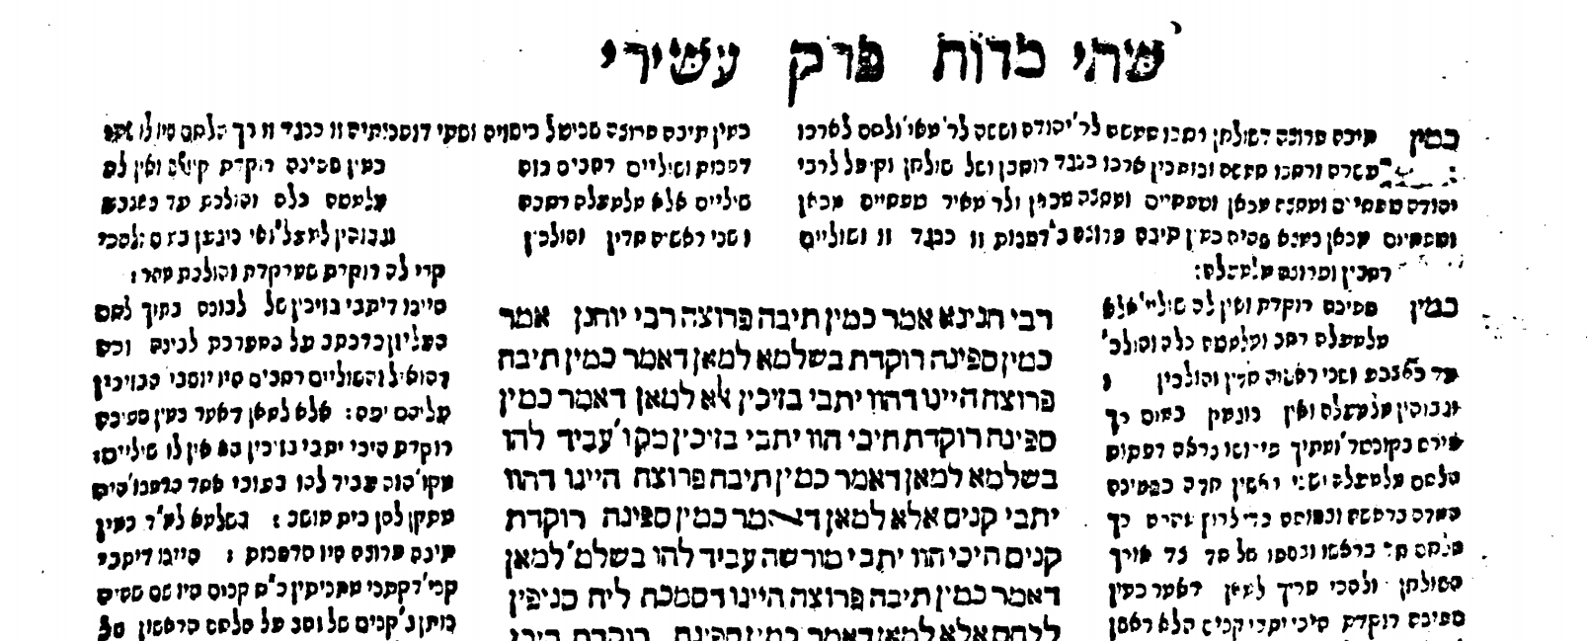
The first printed edition to contain the two diagrams is Frankfurt am Main 1720 (“שנת "מנחת יהודה)
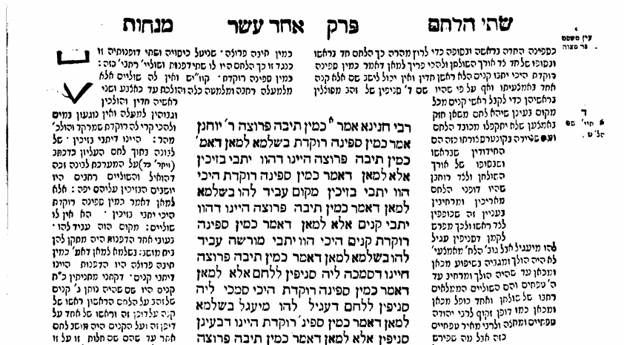

It is unlikely that the editors of the Frankfurt am Main edition had a manuscript of Rashi ( or of Tosafot). It is possible that the source for their diagrams was the Sefer “Omek Halacha” (first printed in Cracow in 1593 and reprinted in Amsterdam in 1710) which contained these diagrams. The picture on the top right is the תיבה פרוצה and the V shaped figure after the words והולכת עד כאצבע וכו׳ כזה is the ספינה רוקדת.
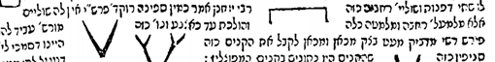
The problem with this is the picture of the תיבה פרוצה is upside down. The editors of the Frankfurt am Main edition themselves say that sometimes they drew the diagrams as they understood them to be. In the forward to Masechet Berachot, point number 15, they write:
"עוד נעשׂו כל הציורים בדקדוק כפי הראוי לפי הבנת הפשט באר היטיב וחד מהם לא נעדר"
Many modern editions of Menachot include more detailed diagrams of this “boat”, showing it to be more curved. Jastrow translates the ספינה רוקדת as a “rocking ship (with a curved bottom.) An example of some of the discomfort with the straight V shape comes from the Daf Yomi Advancement Forum website. http://www.dafyomi.co.il/ where it writes:
“Rebbi Yochanan maintains - that they were shaped like a rocking boat (i.e. like a letter 'vee' [but with a less acute angle]).”
The English Soncino edition of Menachot ( London 1935), while using the words “V -shaped” to describe the boat, presents a picture which shows the boat to be curved.
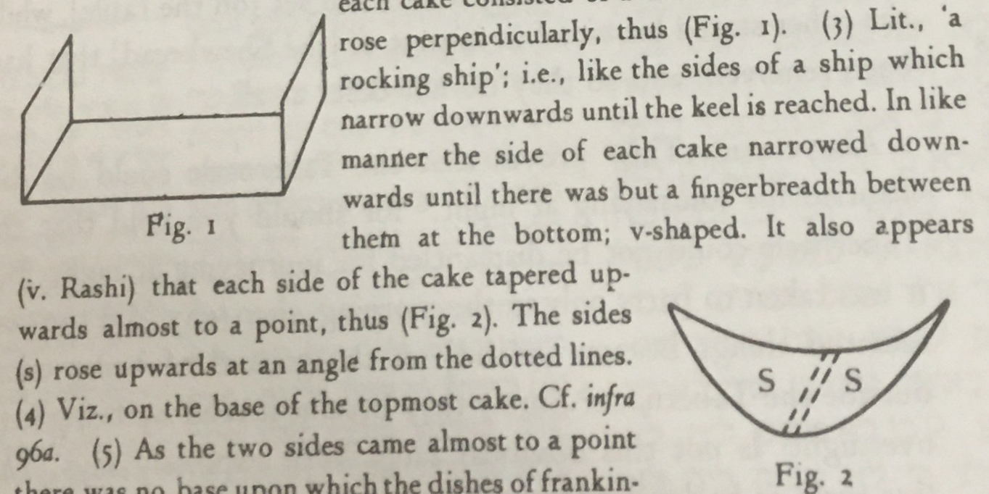

We do have one manuscript of Rashi on this part of Menachot which is identified as follows:
The National Library of Russia, St. Petersburg, Russia Ms. EVR IV 25
http://aleph.nli.org.il:80/F/?func=direct&doc_number=000159163&local_base=NNLMSS
Perhaps it is a bit helpful to this discussion as it shows the ספינה רוקדת to be more curved. ( second line from the bottom)
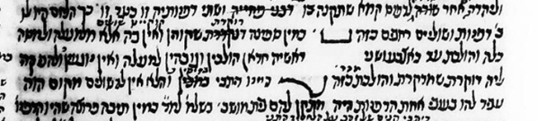
Finally, these comments by Les Saidels, who has done much research on the breads of the Beit HaMikdash, give some context to the difficulty caused by the V shaped diagram. In an email to me, he stated as follows:
“I consulted with a number of maritime archaeologists from around the
world to try ascertain whether there was any kind of vessel that had a V
shaped hull, ever in history, but more aptly at the time of R' Yochanan.
As it happens, there has never been a vessel in history with a V shaped
hull, for the simple reason that it would not sit stably in the water and
would flop over to one side. The only exceptions
to this are some modern catamaran designs which feature a V shaped
hull but achieve stability from the crossbeams connecting the
catamaran.”

He goes through a lengthy analysis of all the sources and reaches the conclusion that Rashi most likely was referring to a boat with a curved bottom which existed at his time, which looked like this:
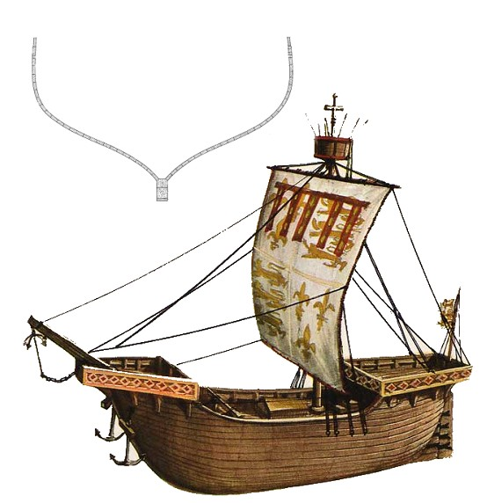

Text, translation and commentary courtesy of Sefaria.org (The William Davidson digital edition of the Koren Noé Talmud, with commentary by Rabbi Adin Even-Israel Steinsaltz )
There is discussion on whether what is shown as Rashi in our editions of Menachot was actually written by Rashi. However Rav Betzalel Ashkenazi ( author of Shita Mekubetzet) indicates that the Rashi starting from chapter 11 was in fact written by Rashi. ( see his note on 94a recorded in the Vilna Shas מכאן ואליך הוא פירוש רש״י ז״ל)
Jastrow translates ספינה רוקדת as a rocking ship ( with a curved bottom). Otzar Loazai Rashi says that it is called a ספינה רוקדת… …מפני שקרניה (הקורה הארוכה המהווה את חוד הספינה מלמטה) חד והיא מרחפת על פני המים
Aside from manuscripts, there are three important sources for diagrams when they started appearing after an absence of almost 200 years from Bomberg ( circa 1520) to Berman Frankfurt an der Oder ( circa 1697). By then (according Rabinowitz in his Maamar) there were no (or very few manuscripts) around so the diagrams had to come from the Sevara of the editors or from these books. - Chochmat Shlomo – There is none on Menachot - Chochmat Manoach -None on this Daf - Omek Halacha

