צייר בקונטרוס כמין ט״ית
By Eli Genauer

Menachot 74b and 75a

Mishnah on 74b "כמין כי"

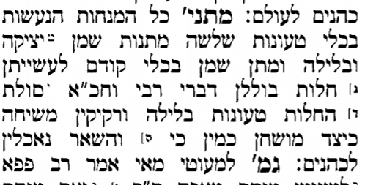

Meal offerings that are made in a vessel need three applications of oil…..The Mishnah concludes…
החלות טעונות בלילה ורקיקין משיחה.כיצד מושחין? כמין כי
The loaves require mixing (with oil) and the wafers require anointing (with oil). How were they anointed? In the form of a Khi.
The Gemara on 75a explains
מאי כמין כי? אמר רב כהנא כמין כי יווני
The khi is a Greek (letter)
Tosafot indicate that Rashi drew this Greek letter khi to look like a ט״ית
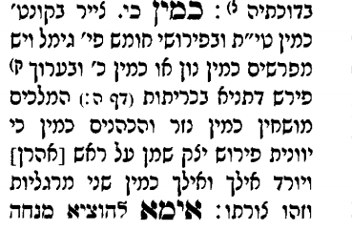
There is no Rashi on the Gemara on 75a so Tosafot are referring to the Rashi we find on the Mishnah on 74b. It is included in the Vilna Shas under the title “Rashi K’tiv Yad”
You have the idea that the Khi looked like a ט״ית as Tosafot indicate. But aside from that, the last three words give us another “picture” of what the Khi looked like… like the space between the thumb and the forefinger. One can imagine a “U” shape. But, despite Tosafot indication that Rashi drew a picture of the Khi, we find no picture in this Rashi.
Thankfully, we have access to the manuscript used in the “Rashi K’tiv Yad” which is known as Vatican ebr. 487
https://digi.vatlib.it/view/MSS_Vat.ebr.487. To access the specific page, go to page 48v.
The bibliographic record of the National Library of Israel notes that according to Rav Betzalel Ashkenazi, this manuscript was the authentic text of Rashi for our section of Menachot.
נוסח זה של רש"י הוא הנוסח האותנטי. במהדורת התלמוד של האלמנה והאחים ראם נדפס נוסח זה למנחות עב ע"ב-צד ע"א מתוך העתקה של ר' בצלאל אשכנזי שנרשם בשולי דפוס. ר' בצלאל טען שזהו הנוסח האמיתי של רש"י לפרקים ז-יא.
Here it is on Menachot 74b
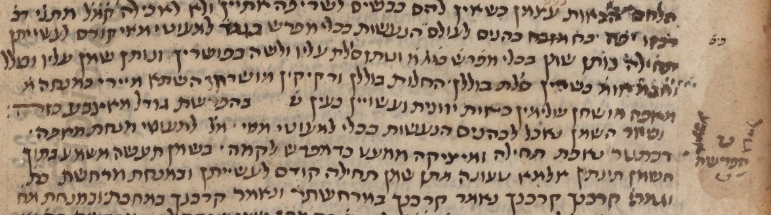
In the body of the text there is a picture of a ט. It also has the word “Kazeh” after B’Hafrashat Godel Ma’Etzbah ( separating the thumb from the finger). It refers to the picture on the right side which shows where the thumb, space and finger are. It has the letter ט inside of it probably to indicate that the ט and B’Hafrashat Godel Ma’Etzbah are the same thing. To seal the deal, it shows a “U” shaped figure underneath.
It is then entirely possible that Tosafot were looking at a Rashi manuscript ( or possibly a K’Tav Yad of Rashi himself) which had a picture, as they indicate by writing צייר בקונטרוס כמין ט״ית

